SIMATS ENGINEERING (SAVEETHA SCHOOL OF ENGINEERING)
Department of Computer Science and Engineering

CO5 - ASSESSMENT TOOL 2 – Coding Challenge

Course Code: | DSA0404 | Course Title: | FUNDAMENTALS OF DATA  SCIENCE
CO Assessed: | CO5 –Coding Challenge | Assessment: | Assessment Tool 2–Coding Challenge
Weightage: | 40% of CIA | Total Marks: | 100
CO5 Statement: | To understand the concept of supervised and unsupervised methods in machine learning
Student Name: | Ramya Y | Reg. No.: | 192424397
Section / Batch: | 2024 | Date: | 26-08-2026

Code of Conduct
I Ramya Y (192424397) (Name / Reg No) certify that this submission is my original work and that I have adhered to the guidelines specified for this assessment. I understand that any violation of academic integrity rules will result in disciplinary action.
Signature of the Student: Ramya Y

Criteria | Weight age | Level 4 – Exemplary | Level 3 – Proficient | Level 2 – Developing | Level 1 – Beginning | Marks
Understanding of Case | 25 | Thorough  understanding; clearly identifies all key issues | Good understanding with most issues identified | Basic understanding; some issues missed | Poor understanding; problem not identified correctly
Application of Concepts | 25 | Effectively applies relevant concepts to analyze the case deeply | Applies appropriate concepts with minor gaps | Limited application of concepts | Fails to apply relevant concepts
Analysis | 20 | In-depth analysis with strong reasoning and insights | Good analysis with logical reasoning | Basic analysis with limited depth | Weak or no analysis; lacks reasoning
Solution Design | 20 | Innovative, feasible solutions with strong justification | Logical solutions with  adequate  justification | Basic solutions with weak justification | Incorrect or no solution provided
Clarity | 10 | Clear, well-structured, and easy to understand | Organized and understandable presentation | Limited clarity and structure | Poor clarity; difficult to understand

Q21. Implement polynomial regression by manually engineering polynomial features (no PolynomialFeatures) up to degree
10 on a small dataset, and demonstrate overfitting as degree increases using train/test error curves. Then fix the overfitting
using regularization (Ridge) and re-plot.

Source Code:
import numpy as np
import matplotlib.pyplot as plt
from sklearn.model_selection import train_test_split
from sklearn.linear_model import LinearRegression, Ridge
from sklearn.metrics import mean_squared_error

# Small dataset
x = np.array([1,2,3,4,5,6,7,8,9,10])
y = np.array([3,5,7,8,11,13,14,18,20,25])

x = x.reshape(-1,1)
X_train, X_test, y_train, y_test = train_test_split(
x, y, test_size=0.3, random_state=42
)

degrees = range(1,11)
train_err, test_err = [], []
ridge_train, ridge_test = [], []

for d in degrees:
# Manual polynomial features
Xtr = np.hstack([X_train**i for i in range(1,d+1)])
Xte = np.hstack([X_test**i for i in range(1,d+1)])

# Polynomial Regression
model = LinearRegression()
model.fit(Xtr, y_train)

train_err.append(mean_squared_error(y_train, model.predict(Xtr)))
test_err.append(mean_squared_error(y_test, model.predict(Xte)))

# Ridge Regression
ridge = Ridge(alpha=10)
ridge.fit(Xtr, y_train)

ridge_train.append(mean_squared_error(y_train, ridge.predict(Xtr)))
ridge_test.append(mean_squared_error(y_test, ridge.predict(Xte)))

# Plot errors
plt.plot(degrees, train_err, 'o-', label='Polynomial Train')
plt.plot(degrees, test_err, 'o-', label='Polynomial Test')
plt.plot(degrees, ridge_train, 's--', label='Ridge Train')
plt.plot(degrees, ridge_test, 's--', label='Ridge Test')

plt.xlabel("Polynomial Degree")
plt.ylabel("Mean Squared Error")
plt.title("Overfitting and Ridge Regularization")
plt.legend()
plt.grid()
plt.show()

Output:
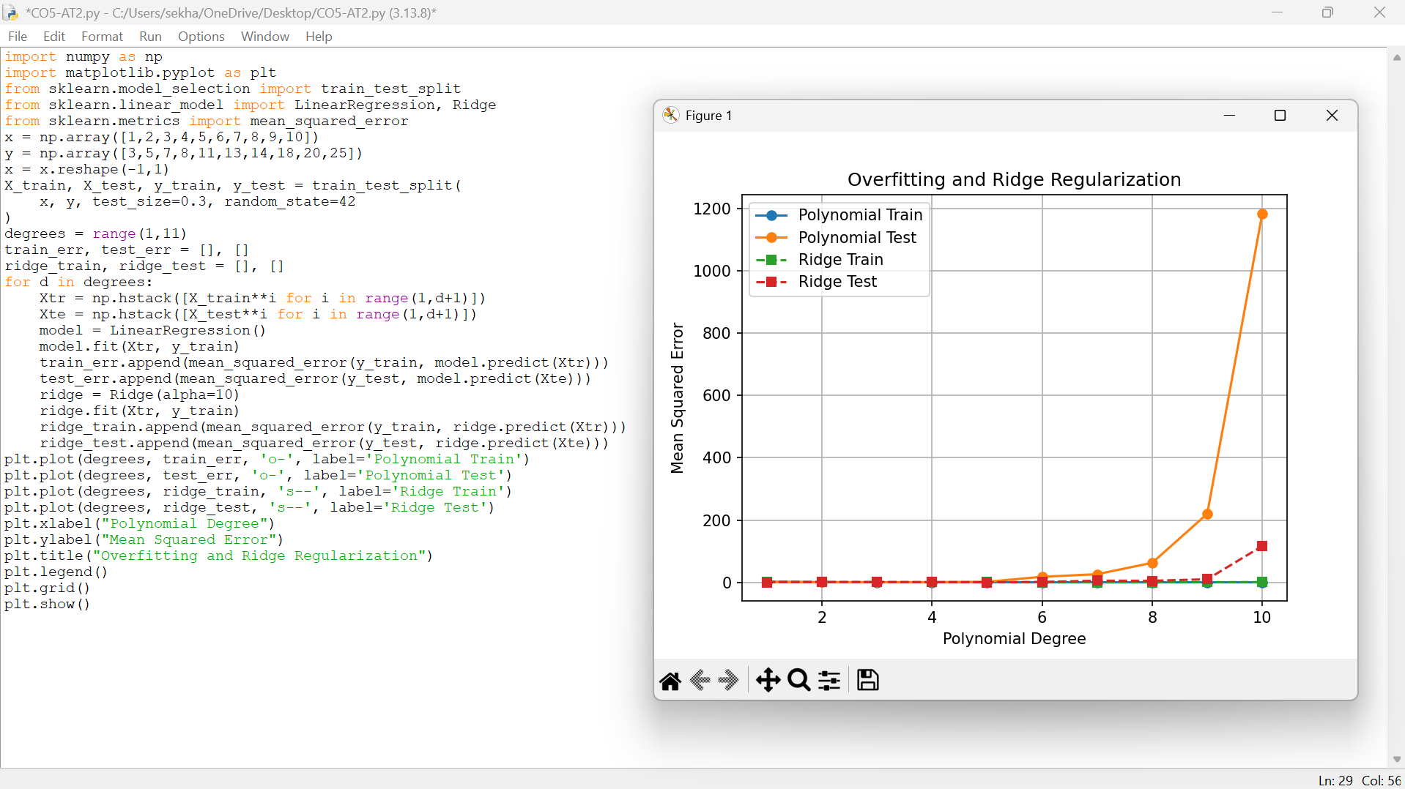

Proof:



